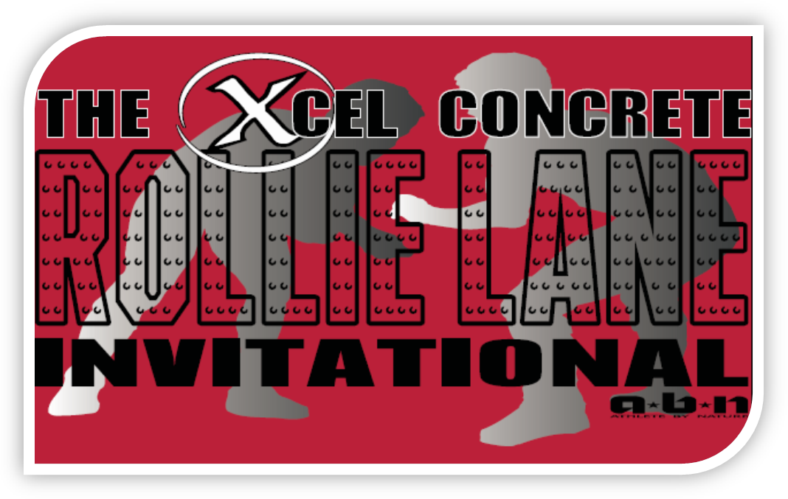

Co-Sponsored by:

Dear Coach:

The Xcel Concrete Rollie Lane Invitational is pleased to have your team to participate in the 2017 tournament. We are looking forward to the best tournament ever. Tournament format will be a 64 man bracket format, with a POD style second chance tournament for all those eliminated on the 1st day. We are excited about several new squads coming in and some teams returning after being gone for a few years. This year’s field looks to be as tough as ever!

New specifics for this year’s tournament:
- ALL ENTRIES DUE BY January 3rd 10:00 pm. Seeding meeting on January 4th^{th} at 5:00 pm. Reminder will be sent out closer to that date. (entries will be submitted thru TrackWrestling).
- Idaho has the 98 lb. weight class, all out of state teams are encouraged to bring a 98 lb. wrestler
- There will be a 2nd chance POD tournament for wrestlers that are put out the 1st day, all wrestlers will be getting an additional 3 matches!
- 2nd weigh-ins will follow National Weigh-in Rules and will take place SATURDAY MORNING (this is for ALL wrestlers…2nd chance wrestlers WILL weigh-in again!)
- 1 DATE TOURNAMENT: Idaho coaches we have been granted the right to begin this tournament prior to 3:00 pm on Friday and still have the event count as one date!
- Teams wanting in extra wrestlers beyond the 15 weight class representatives will be charged $20/wrestler if they are entered into the tournament.

WHEN: January 6-7, 2017

TIME: Friday -- Weigh-ins: 9:00 a.m. (scratch +2lb)
Coaches Meeting: 10:00 a.m.
Wrestling Begins: 11:00 a.m.
11 – 12:30p Championship Rd 1
12:30p – 2:30p Championship Rd 2/Consolation Rd 1
2:30p –4:00p Consolation Rd 2
4:00p – 6:00p Championship Rd 3/Consolation Rd 3
6:00p – 7:00p Consolation Rd 4
- All matches will be wrestled (12 mats)

2nd Chance Tournament Weigh-ins: 9:00 pm Weigh-ins for ALL wrestlers! (scratch +2)

Saturday --
Weigh-ins: 7:00 a.m. Rollie Lane Day 2 participants (scratch +2lb)
Coaches Meeting: 8:25 a.m.
Wrestling Begins: 9:00 a.m.
9a – 11a Championship Quarters/Consolation Rd 5 (6 mats)
11a -12:00p Consolation Rd 6 (6 mats)
12:00p – 1:30p Championship Semifinals/Consolation Rd 7
1:30 – 2:00 Lunch Break
2:00p – 3:00p Consolation Rd 8 (Consolation Semifinals)
3:30 p.m. Parade of Champions
4:00 p.m. Championship Matches (2 mats)
1st-2nd , wrestling 2 weights at a time
Placing Matches, 3rd-6th (4 mats)
5:30 p.m. Team Trophy Presentation
WHERE: The Idaho Center – Nampa, Idaho
NO EXCEPTIONS
COST: $100- for 1 wrestler
$225- for 2-6 wrestlers
$325*- for 7-15 wrestlers ****Teams must pay prior to the tournament dates…if not a $50 late fee will be assessed….this was stated on team’s contract
*$20/wrester for each wrestler over a team’s allotted 15 spots

*indicates extra fee for wrestlers beyond 15 individuals

This years tournament will boast 62+ teams from Idaho, Washington, Oregon, Nevada and Colorado. Communication is key for us to run this tournament as smoothly as possible. Below you can find my contact information. Please do not hesitate to contact me regarding any issues.

Todd Cady, Tournament Director – Columbia High School
Phone: 208-498-0571 ext. 6540 (work)
208-880-2810 (cell)
Fax: 208-498-0573 or
I can be contacted by e-mail at: tcady@nsd131.org
- General Information:
  - The top 16 kids at each weight will be seeded if possible. The remainder will be drawn into the tournament, splitting same conference schools to the best of our ability.
  - #2 wrestlers will be admitted if there is room in the weight class, preference will be given to returning Rollie Lane Placers, returning State Placers, returning State Qualifiers, and current season VARSITY winning percentage.
  - Seeding WILL NOT be changed! The only information that will be discussed at the Coaches Meeting prior to the tournament will be scratches, name changes, etc. NO EXCEPTIONS! The only seed changes will be bouncing seeds based on scratches!!! Each year we have coaches NOT send us up to date or COMPLETE seeding information….the seeding committee will not research your wrestler…..we welcome any and all coaches to assist with seeding meeting.

- Seeding Information:
  - Seeding Criteria to be used:
    - Head to Head – NO COMMON OPPONENT!
    - Rollie Lane Champion @ same weight
    - Rollie Lane Champion @ different weight
    - 3 X State Champion
    - 2 X State Champion
    - 2016 Fargo Junior All-American (any style, higher place getting higher seed, regardless of weight class)
    - 2016 Fargo Cadet All-American (any style, higher place getting higher seed, regardless of weight class)
    - Placer at 2016 Reno Tournament of Champions (higher place getting higher seed, regardless of weight class)
    - Champion 2016 Tri-State Wrestling Tournament
    - 1 X State Champion
    - State Runner-up
    - Rollie Lane Placer
    - Placer 2-6 at 2016 Tri-State Wrestling Tournament (higher place getting higher seed, regardless of weight class)
    - State Placer
    - Record

- TEAM SCORING
    - Traditional tournament scoring will be used for your #1 declared wrestler at each weight.

- ENTRIES
    - Trackwrestling entry details will be sent in December.

Directions:
Interstate I84 westbound from Boise - Take Exit 38 and continue right approximately one-half mile to the traffic light.
Continue straight through the traffic light and drive one-quarter mile and turn right into the Idaho Center's parking lot.
Interstate I84 eastbound from Caldwell and Ontario Oregon - Take Exit 38 and turn left and drive approximately one-half mile to the traffic light.
Continue straight through the traffic light and drive one-quarter mile and turn right into the Idaho Center's parking lot.
Franklin Road (Meridian) - Continue west on Franklin Road past Star Road approximately three quarters of a mile and turn right into the
parking lot (entrance past the Service Entry). This parking lot has the most handicapped parking spaces.
State Street (Highway 44), Chinden Boulevard, and Cherry Lane - Continue west past Star Road for one mile and turn left onto Idaho Center Blvd.
Continue south (three miles Highway 44, 2 miles Chinden Boulevard, and one-half mile from Cherry Lane.). After crossing the railroad tracks turn
left at the second entrance into the main parking lot.

Host Hotel:


Holiday Inn Express
4104 E. Flamingo Ave
Nampa ID. 83687
208-466-4045
Mention Rollie Lane Invitational

2 Queens w/ hot breakfast $99/night

